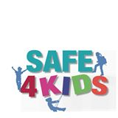
Food Allergy Symptoms in Children
Children with food allergies might communicate their symptoms in the following ways:

- It feels like something is poking my tongue.
- My tongue (or mouth) is tingling (or burning)
- My tongue feels like there is hair on it.
- My mouth feels funny.
- There’s a frog in my throat; there’s something stuck in my throat.
- My tongue feels full (heavy).
- My lips feel tight.
- It feels like there are bugs in there (to describe itchy ears).
- My lips feel tight.
- It feels like there are bugs in there (to describe itchy ears).
- It (my throat) feels thick.
- It feels like a bump is on the back of my tongue (throat)

Source: The Food Allergy & Anaphylaxis Network. Food Allergy News. 2003;13(2).

